**Exploratory Data Analysis On CrunchBase DataSet**

**Net Funding( in billion USD) raised across the top 20 market sectors**

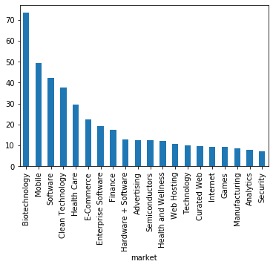

Mobile and Technology are among the top 3 as one might expect. Biotechnology takes the top place, showing its increasing importance. Healthcare and Ecommerce are also areas of interest as seen.

**Net Funding( in 100 millions USD) raised across the top 10 countries**

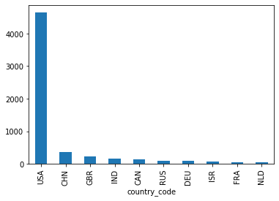

As we can see, most of the funding ( and by a wide margin) is occuring in the US, so let’s try to further drill down to the specific states receiving this funding within the US.

The graphs also show that China, UK and India are the next three best places to raise funding.

**Net Funding( in 100 millions USD) raised across the top 10 regions**

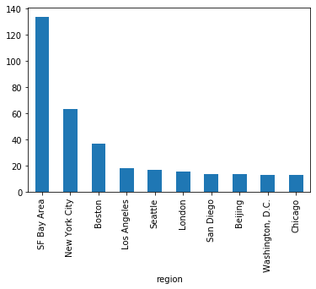

As one might expect, most of the funding is concentrated in the Bay Area, as it's widely known as the tech hub of the world. What follows are other major well known US cities like NYC, Boston, LA, Seattle, all centres to big tech corporations.

London and Beijing, the capitals of two other influential companies also make an appearnce in the top 10 places to be to found a company.

**Number of companies in each market ( top 15 )**

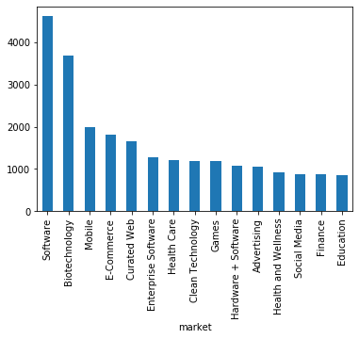

This is in sync with the top market sectors by total funding, except that the total number of companies in the “Software” domain are the most.

**Average funding received by a company in a particular market sector ( in millions USD)**

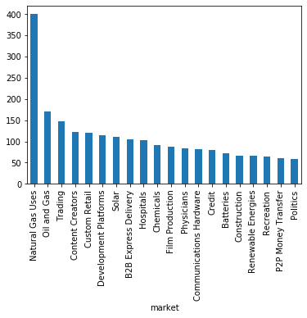

Makes sense to see industries in the energy sector as needing the most amount of funding in general given the operation intensive nature of the business.

**Average Number of Funding rounds for the average highest funded markets ( top 10 )**

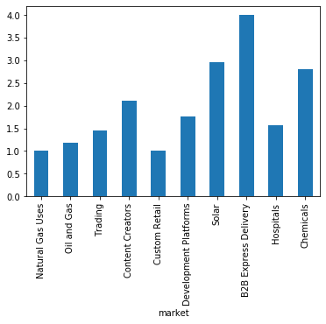

We have between 1-4 funding rounds on average for the most funded market sectors.

**Average funding in companies which were closed ( in USD millions)**

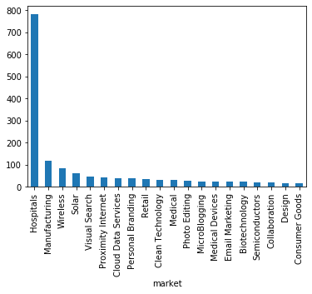

Most of the money spent on average in companies in the hospital sector was eventually wasted since the businesses were eventually shut.

**Number of Companies across sectors that are shut down**

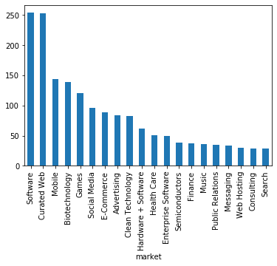

Not much to conclude from here, since most of the companies that are founded are in software, it's not surprising to see their count high in the companies that closed category as well.

**Total funding raised across the years**

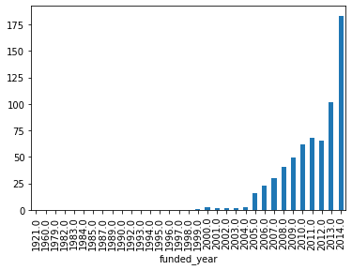

As one might expect, this shows an increasing trend, and over the last year funding has increased sharply by about 75%.

**Total number of firms funded as part of various funding round types**

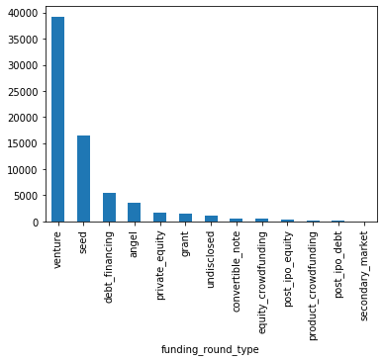

**Total funding across various stages ( in billions USD)**

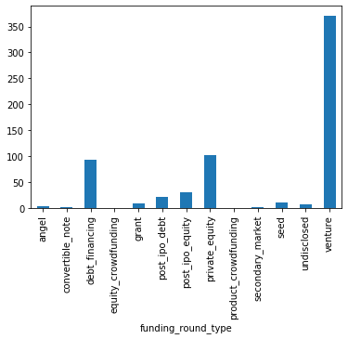

Early stage Venture capital is where most of the funding happens, in terms of total money pumped into the ecosystem. Far behind at second place is private equity, followed by debt financing. Let’s see what the average funding looks like at various stages.

This is in line with the graph before, which shows the count by funding types. Venture capital is the most frequent form of funding, and also contributes the most in absolute amount. An interesting thing to check next is the funding given on an average across different funding types.

**Average funding at various stages (in millions USD)**

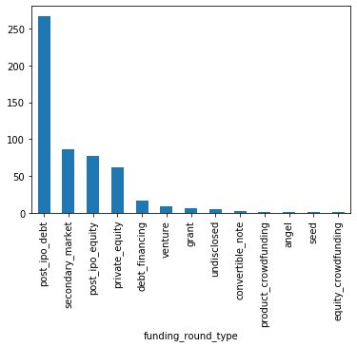

Interestingly, while venture capital contributes most of the funding happening in the market on an absolute scale, on a per firm basis, most of the funding happens later on, as evidenced by the above graph where post IPO debt and equity occupy the top 3 places, while venture is far behind.

This is in line with expectations, since venture capital is pumped in the initial stages when only a proof of concept is to be developed, while post IPO financing would typically be at a later stage when the company has grown and has more need for capital to expand and handle operations.

Let’s drill down to various stages in the venture capital stage, since this is by far the most dominant stage.

In terms of count, Series A dominates, followed by the rest in sequential order.

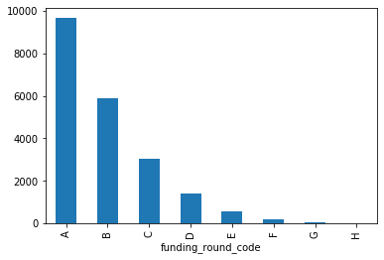

Let’s look at it terms of total money raised in each series.

It’s again as expected, most of the money coming early on, though series B is more than series A.

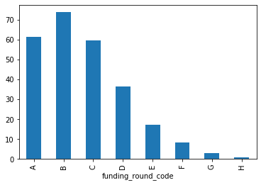

Let’s see how it stands on an average level next.

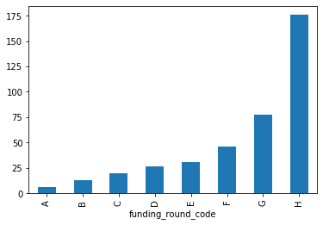

As seen earlier as well, more money is pumped into a firm as the time progresses, so funding per series on average increases from Series A to Series H.

Very few firms go to Series H, but those that do, get on average way more money than what is given Series A onwards.

**Top Investor categories:**

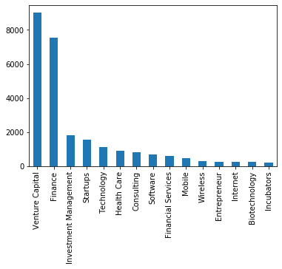

Most of the investors are VC firms and Finance/Investment Management firms, as expected.

Subcategories of companies getting highest funding ( in billions USD ):

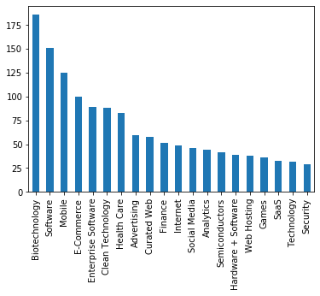

**Attaching the market bar graph for comparison:**



The categories are pretty much in line with the market sectors, and not much insight is gained from subcategories, except that a firm which mixes the top few subcategories can expect to raise higher funding, such as a mobile software company in the biotechnology field.

**Top investors by funding amount ( in billions USD):**

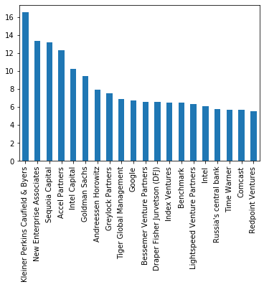

No surprises here, all the big names make an appearance as expected.

Next let’s see which market sectors these big names invest in.

**Below are top sectors where the top 20 investors invest in ( in billions USD )**

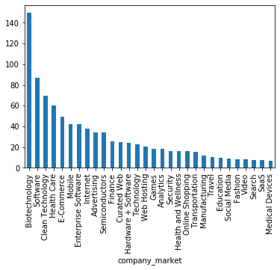

This is also pretty much similar to the top invested sectors overall.

**Top investor/market sector combination by funding amount ( in billions USD):**

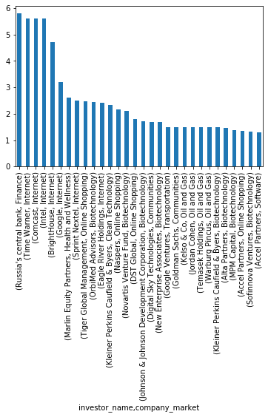

Worth noting that not all the top investors by funding amount appear on the top 30 list of investor/market sector category, which means some of the top investors also have diversified investments in other market sectors.

**Funding by years:**

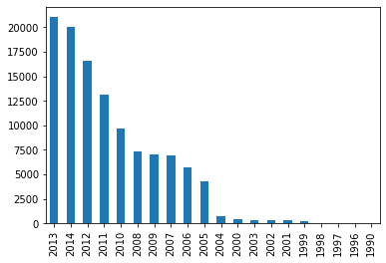

Most of the funding has taken place recently, or reflects the bias of the data being captured in that most recent data is more accurate.

**Funding by quarters:**

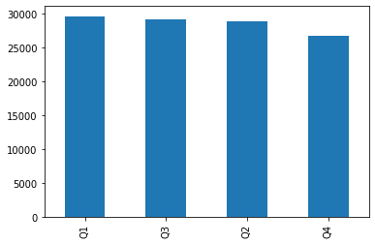

No clear winner here, almost uniform across the quarters.

**Funding by months:**

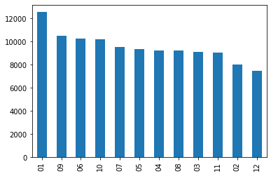

Most of it in January, not much difference across the rest of the months

**Counts of companies acquiring and companies acquired :**

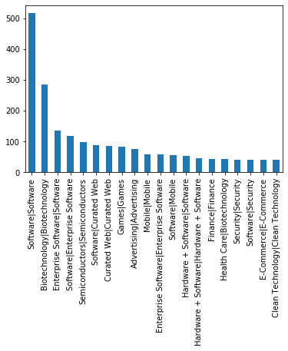

As expected, most of the acquisitions happen in the same sector ( or related sector) to make use of synergies and make the combined entity more profitable.

**Combinations of acquirer region and acquired region :**

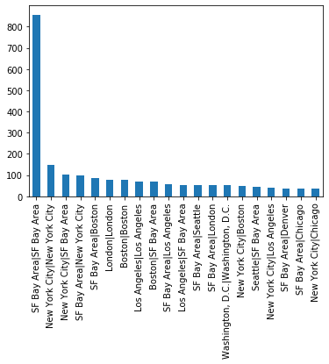

Most of the acquisitions happen within the same or neighbouring regions, underscoring the effect of vicinity.

Almost all the acquisitions take place in USD, telling us that most of the acquired firms were based in the US, or that USD is the dominant currency :

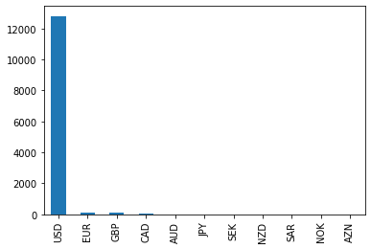

**Acquisition count by years:**

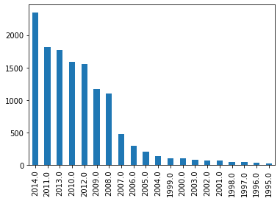

Most of the acquisitions show an increasing trend by years.

**Acquisitions by quarter:**

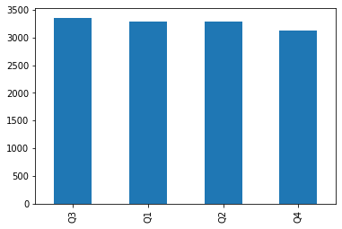

Almost uniformly across the quarters.

Acquisitions by month, interestingly show that most of these happen in january, with not much difference across the other months:

